sir ye dashboard furniture ky cash flow (cash receive or spent karny kai bad wali rakam) ki report hai basically yeh report 2018 sa lai kar 2025 tak hai jis mai hum nai Cash flow, Business plan, Sales by category, Remain in warehouse, Power Production and lost working time kai bary main ap ko detail dain gy with data and charts .

**Cash Flow:**

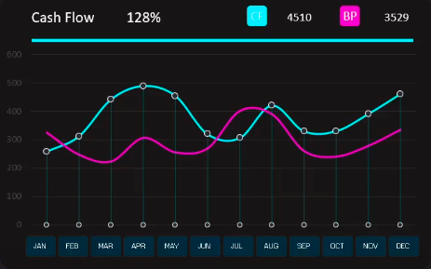

Sab sai phly main cash flow kai bary mai batata hon is main ye  cash flow means hum customer sai payment received kar kai or spent kar kai like bills or employee's salaries kai bad jo cash bach jata hai wo cash flow hota hai or  business plan hamary expectation hoti hai. 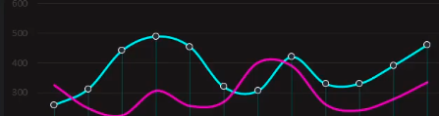Or ye lines earning ko represent karti hai kai kitni earnings ho rah hain like blue line is for cash flow and pink line is for business plan in bottom their is month jb hum click Karin gy to os month ky detail a jay gi

**Distribution By Category:**

basically furniture sales four category per hai high tech, Loft, Pop Art, Vanguard. hm is per click Karin gy to os ky information ajay gi with percentage.

**Remains in warehouse:**

jo four categories hai furniture ki jo filhal hamary warehouse main aby sale nahi howi hain

**Production Power:**

Ye hamari production power hai mtlb hamari is saal production ky kity speed hai jo saal hm select karin gy to os ky hisab sy hamry power of production aa jaiy gi

**Sales By Categories:**

ye basically four categories ki sale hain with prices jo ky lines chart per mustamil hai or her ye line ek catergory zahir karty hai

**RESOURCE DISTRIBUTION**

Is main do types hain Energy and material in enery yahan per total 6 workshop hai jo kyye ye chart bataraha hai ye kitny energy ky ssaat working ho rahi hai or in Material se ye pata raha hai ye yahan material kita material hai with percset materua hai

**Lost Working Time:**

Ye hamary working time jo ky hm ny work shop ny lost kiya hia

Conclusion:

Cash flow aur sales performance ka deep analysis ye show karta hai ke improvement aur strategic action ke liye kaafi important areas maujood hain. Winning strategies mein shamil hai top-selling categories par focus karna, consumer behavior ko samajhna, aur operational efficiencies ko optimize karna taake growth sustain ki ja sake. Ye approach resources ko demand ke saath align karta hai, jo ke increased profitability ka rasta humwar karta hai.